900221-000-00-KM-01, Introduction to Python Programming, NQF Level 4, Credits 2
Facilitator Guide
Module One (1)

Module Code | 900221-000-00-KM-01
NQF Level | 4
Credits | 2
Skills Programme ID Number | SP- 230375
Curriculum Title | Java Programmer
Curriculum Code | 900221-000-00-00

Name
Contact Address
Telephone (H)
Telephone (W)
Facsimile
Cellular
E-mail

Note to the learner
This Learner Guide provides a comprehensive overview of the module. It is designed to improve the skills and knowledge of learners, and thus enabling them to effectively and efficiently complete specific tasks.

Purpose of the Module
The main focus of the learning in this knowledge module is to build an understanding of the fundamentals of Python Programming language
The learning will enable learners to demonstrate an understanding of:
- KM-01-KT01: Computers 10%
- KM-01-KT02: Introduction to Python programming 10%
- KM-01-KT03: Introduction to suitable IDE (Integrated Development Environment) 5%
- KM-01-KT04: GIT 10%
- KM-01-KT05: Problem solving in programming 10%
- KM-01-KT06: Life cycle for developing a solution 15%
- KM-01-KT07: Python core concepts 10%
- KM-01-KT08: Python syntax 15%
- KM-01-KT09: Python variables 15%

Provider Accreditation Requirements for the Knowledge Module
Physical Requirements:
- The provider must have lesson plans and structured learning material or provide learners with access to structured learning material that addresses all the topics in all the knowledge modules as well as the applied knowledge in the application.
- QCTO/ MICT SETA requirements

Human Resource Requirements:
Lecturer/learner ratio of 1:20 (Maximum)
- Qualification of lecturer (SME): o NQF 5 qualified in industry recognised qualifications with 1-year experience in the IT industry
- Cybersecurity vendor certification • Assessors and moderators: accredited by the MICT SETA

Legal Requirements:
- Legal (product) licences to use the software for learning and training
- OHS compliance certificate

Venue, Date and Time:
Consult your facilitator should there be any changes to the venue, date and/or time.Refer to your timetable.

Assessments
Integrated Formative Assessment: The skills development provider will use the curriculum to guide them on the stipulated internal assessment criteria and weighting. They will also apply the scope of practical skills and applied knowledge as stipulated by the internal assessment criteria. This formative assessment leads to entrance into the integrated external summative assessment.

Integrated Summative Assessment: An external integrated summative assessment conducted through the relevant QCTO Assessment Quality Partner is required to issue this qualification. The external integrated summative assessment will focus on the exit level outcomes and associated assessment criteria.

Skills Programme Rationale
In South Africa, according to the 2020 list of occupations in high demand: Technical Report (Department of Higher Education and Training) published in 2021 it is clear that the role of the programming and its derived skills programmes have been identified as pivotal by several Sector Education and Training Bodies (SETAs). Responding to the rapid skills demand by supplying Python programmers will thus have a positive impact on the economy.
Python programmers will play a pivotal role in establishing a data-driven culture and currently available advanced technology to manipulate these big data and complex datasets.
It is also important to note that there are great opportunities to become self-employed and the entrepreneurial orientated Python Programmers will form new companies (with the employment creation associated to it).
A demand for competent Python programmers exist in any economic sector, e.g. finance, insurance, healthcare, energy, environmental, government, transportation, agriculture and food. International research also confirms the phenomenal growth in the need for qualified programmers, including Python Programmers.
Typical learners include school leavers and persons who want to enter the ICT sector with programming skills. Minimum requirements are a Gr 11 with Maths Lit and English.

Skills Programme Purpose
A Python Programmer will be able to implement solutions to solve real-life problems in an efficient manner applying a knowledge and understanding of the principles of programming with Python and applicable tools.
Tasks that the learner will be able to know, do and understand after achievement of the skills programme include:
- Create well-written and readable Python programs, using a disciplined coding style, including comments and indentation standards.
- Work collaboratively in a team and execute version control.

Entry Requirements
- Grade 11 with Maths Lit and English.
- Access to equipment, internet connectivity and how to work remotely

EXIT LEVEL OUTCOMES

Exit Level Outcomes (ELO) 1
Describe the basics of Python Programming
Associated Assessment Criteria
- Fundamentals of the Python programming language are explained.
- The basic concepts and methods of object-oriented programming and object-oriented design are described.
- The development life cycle as a means of creating applications is described.

Exit Level Outcomes (ELO) 2
Programme effectively using Python frameworks and functionalities
Associated Assessment Criteria
- The use of Python syntax, using the Python API is applied.
- Well-written and readable Python programs are created, using a disciplined coding style, including documentation and indentation standards.
- The ability to troubleshoot problems with application development is applied.

Exit Level Outcomes (ELO) 3
Work collaboratively in a team using GitHub platform
Associated Assessment Criteria
- An ability to work with Git and GitHub functionalities is demonstrated.
- The ability to work collaboratively in a team using Git is applied
- Version control is executed using Git functionalities such as repositories, branches, commits and pull requests.

Session 1: KM-01-KT01: Computers 10%
- IAC0101 Define the functions and features of the respective computer elements


Computers are electronic devices that process and store data, perform calculations, and execute various tasks based on instructions provided by users or software programs. They have become an integral part of modern life and are used in a wide range of applications, from personal computing to scientific research, business operations, and entertainment.
Here are some key aspects and components of computers:
- Hardware: Computers consist of physical components, including the central processing unit (CPU), memory (RAM), storage devices (hard drives or SSDs), input devices (such as keyboards and mice), output devices (monitors and printers), and various peripheral devices like scanners, webcams, and speakers.
- Software: Computers run on software, which includes operating systems (e.g., Windows, macOS, Linux) that manage hardware resources and application software (e.g., web browsers, word processors, games) that users interact with to perform specific tasks.
- Operating System: The operating system is a critical software component that manages hardware resources, runs applications, and provides a user interface for interaction. It also handles tasks like file management, security, and multitasking.
- CPU (Central Processing Unit): The CPU is the "brain" of the computer, responsible for executing instructions and performing calculations. It fetches, decodes, and executes instructions from memory.
- Memory (RAM): Random Access Memory (RAM) is used to temporarily store data that the CPU is actively working on. It provides fast access to data and programs but is volatile, meaning it loses its contents when the computer is turned off.
- Storage: Storage devices, such as hard drives and solid-state drives (SSDs), are used for long-term data storage. Unlike RAM, storage is non-volatile, which means data is retained even when the computer is powered off.
- Input Devices: These devices allow users to provide information to the computer. Common input devices include keyboards, mice, touchscreens, and microphones.
- Output Devices: Output devices display or provide information to users. Monitors, speakers, and printers are examples of output devices.
- Peripherals: These are additional devices that can be connected to a computer to enhance its functionality, such as external hard drives, webcams, and graphics tablets.
- Network Connectivity: Most modern computers have built-in network adapters that enable them to connect to the internet or local networks. This connectivity is essential for accessing online resources, sharing data, and communication.
- Software Applications: Users interact with computers through software applications, which can range from web browsers and word processors to specialized software for tasks like graphic design, video editing, and programming.
- Programming: Computers can be programmed to perform specific tasks or solve problems. Programming languages like Python, Java, C++, and many others are used to create software applications and automate tasks.
- Security: Computer security is a critical concern to protect data and privacy. This includes measures like antivirus software, firewalls, encryption, and user authentication.
- Evolution: Computers have evolved significantly over time. They started as large, room-sized machines in the mid-20th century and have since become smaller, more powerful, and portable. The development of microprocessors, graphical user interfaces, and the internet has played a crucial role in this evolution.
- Types of Computers: Computers come in various forms, including desktops, laptops, tablets, smartphones, servers, supercomputers, and embedded systems. Each type serves specific purposes and has varying levels of processing power and capabilities.
Computers have revolutionized the way we work, communicate, conduct research, and entertain ourselves, making them an essential part of modern society.

Session 2: KM-01-KT02: Introduction to Python programming 10%
- IAC0201 Describe the definitions, functions and features of each topic element

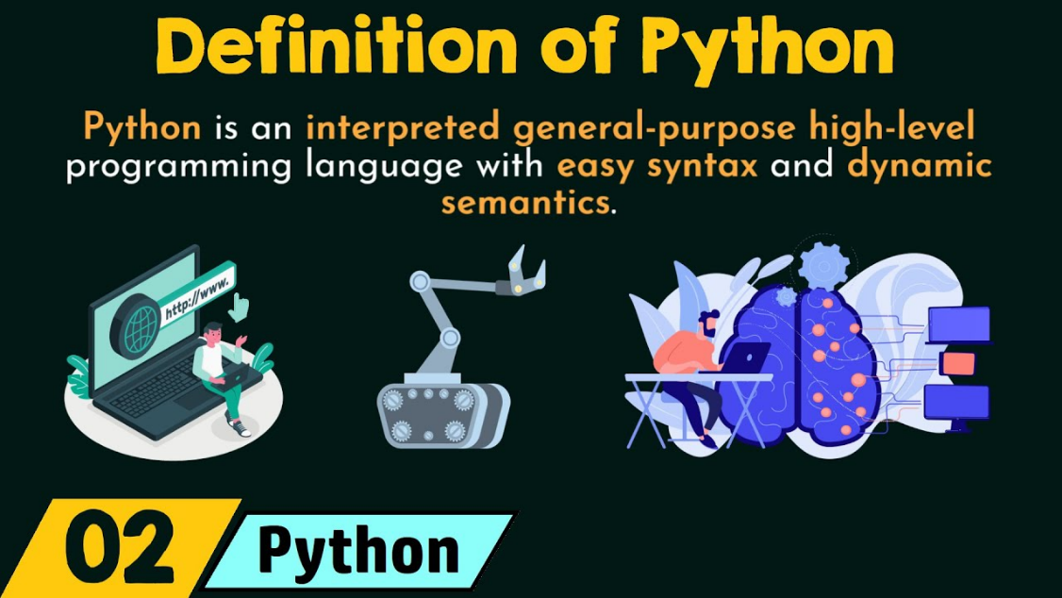
Python is a high-level, interpreted, and versatile programming language known for its readability and simplicity. Created by Guido van Rossum and first released in 1991, Python has gained popularity for a wide range of applications, from web development and scientific computing to data analysis, machine learning, and automation.
Here are some key characteristics and aspects of Python:
- High-Level Language: Python is a high-level programming language, which means it abstracts complex details of the computer's hardware and provides a more user-friendly syntax.
- Interpreted Language: Python is an interpreted language, meaning that code is executed line by line by the Python interpreter without the need for compilation into machine code. This makes development and debugging more accessible.
- Readability: Python emphasizes code readability, with a clean and easy-to-understand syntax that uses indentation (whitespace) to define code blocks. This readability is often referred to as the "Pythonic" way of writing code.
- Multipurpose: Python is a general-purpose language, suitable for a wide variety of applications. It has a large standard library with modules and packages that simplify common programming tasks.
- Dynamic Typing: Python is dynamically typed, meaning that you don't need to declare variable types explicitly. The type of a variable is determined at runtime.
- Cross-Platform: Python is available for various platforms (Windows, macOS, Linux) and is compatible with many other programming languages.
- Open Source: Python is open-source software, which means it is freely available, and the community actively contributes to its development and improvement.
- Extensible: Python can be extended with modules written in other languages like C and C++, allowing you to integrate existing code or take advantage of performance-critical tasks.
- Large Community: Python has a large and active community of developers and enthusiasts, which means there is a wealth of resources, libraries, and frameworks available.
- Web Development: Python is used for web development with frameworks like Django and Flask, making it a popular choice for building web applications.
- Data Science and Machine Learning: Python is widely used in data science and machine learning, thanks to libraries like NumPy, pandas, scikit-learn, and TensorFlow.
- Automation and Scripting: Python is excellent for writing scripts and automating repetitive tasks, making it a valuable tool for system administrators and DevOps professionals.
- Education: Python is often recommended for beginners due to its simplicity and readability, making it an excellent language for learning programming.
Python's versatility, ease of use, and extensive ecosystem of libraries and tools have contributed to its popularity among both novice and experienced programmers. It continues to play a significant role in a wide range of industries and applications.

Session 3: KM-01-KT03: Introduction to suitable IDE (Integrated Development Environment) 5%
- IAC0301 Explain the definitions, functions and features of each topic element
An Integrated Development Environment (IDE) is a software application or platform that provides comprehensive tools and features to assist developers in creating, testing, and managing software applications. It is a single integrated environment that combines various development tools, such as code editors, compilers, debuggers, and project management tools, into a unified workspace. IDEs are designed to streamline the development process, enhance productivity, and facilitate the writing, testing, and maintenance of code.
Key characteristics and components of an IDE include:
- Code Editor: An IDE typically includes a code editor with features like syntax highlighting, code completion, and code formatting, making it easier for developers to write and edit code.
- Compiler/Interpreter: Many IDEs come with built-in compilers or interpreters for various programming languages, allowing developers to execute their code within the IDE.
- Debugger: IDEs often provide debugging tools that help developers identify and fix issues in their code, such as breakpoints, variable inspection, and step-by-step execution.
- Project Management: IDEs allow developers to create and manage projects, organize files and directories, and track dependencies. This makes it easier to work on complex software projects.
- Version Control Integration: Many IDEs integrate with version control systems like Git, enabling developers to track changes, collaborate with others, and manage code repositories.
- Build and Deployment Tools: IDEs often include tools for building, packaging, and deploying software applications, simplifying the deployment process.
- Testing and Profiling: Some IDEs offer testing frameworks and profiling tools to help developers identify bottlenecks and optimize their code.
- Code Templates and Snippets: IDEs may include code templates and snippets that help developers write code faster by providing predefined code blocks for common tasks.
- Documentation and Help: IDEs often offer built-in documentation and access to online resources, tutorials, and community support to assist developers in learning and using programming languages and frameworks.
- Extensions and Plugins: Many IDEs support extensions and plugins, allowing developers to customize and extend the IDE's functionality to suit their specific needs.
- Cross-Platform Support: Some IDEs are cross-platform and can be used on multiple operating systems, while others are specific to certain platforms.
Common examples of IDEs include:
- PyCharm: An IDE for Python development.
- Visual Studio: Microsoft's IDE with support for various programming languages.
- Eclipse: An open-source IDE that supports multiple programming languages.
- IntelliJ IDEA: An IDE primarily used for Java development.
- Xcode: Apple's IDE for macOS and iOS app development.
- Android Studio: An IDE for Android app development.
- NetBeans: An open-source IDE for Java and other languages.
IDEs play a crucial role in software development by providing a centralized environment where developers can write, test, debug, and manage code efficiently. They are especially valuable for larger software projects where organization and collaboration are essential.

Session 4: KM-01-KT04: GIT 10%
- IAC0401 Determine the definitions, functions and features of each aspect

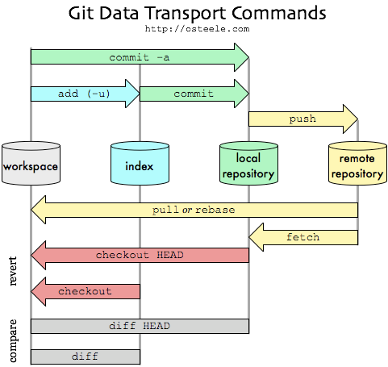
Git is a widely used distributed version control system (DVCS) that enables developers to track changes in their codebase, collaborate with others, and manage software development projects efficiently. Developed by Linus Torvalds in 2005, Git has become a fundamental tool in modern software development. Here's an overview of Git's key concepts and functionalities:
- Version Control:
  - Git tracks changes in a project's files and directories over time, creating a version history.
  - Developers can view, compare, and revert to previous versions of files.
- Distributed and Decentralized:
  - Git is a distributed version control system, meaning every developer has a complete copy of the project's repository, including its entire history.
  - Developers can work independently, commit changes locally, and later synchronize their work with others.
- Repositories:
  - A Git repository is a folder or directory that contains the project's files, along with metadata and version history.
  - Repositories can be hosted locally or remotely on services like GitHub, GitLab, Bitbucket, and others.
- Commits:
  - A commit represents a set of changes to the codebase. It includes a unique identifier (SHA-1 hash), author information, timestamp, and a commit message describing the changes made.
  - Commits are organized chronologically to form a commit history.
- Branches:
  - Git allows developers to create branches, which are separate lines of development. Each branch can have its own set of commits.
  - Branches are useful for working on features, bug fixes, or experiments without affecting the main codebase (often referred to as the "master" or "main" branch).
- Merging and Pull Requests:
  - Developers can merge branches to combine changes from one branch into another (e.g., merging a feature branch into the main branch).
  - On collaborative platforms like GitHub, GitLab, and Bitbucket, developers can create pull requests or merge requests to propose and review code changes before merging them.
- Conflict Resolution:
  - Git handles concurrent changes to the same file by marking conflicts that need manual resolution. Developers can resolve conflicts by editing the affected files.
- Tags:
  - Tags are named references to specific commits. They are often used to mark important points in the commit history, such as releases or milestones.
- Remote Repositories:
  - Remote repositories are copies of the project hosted on a server, facilitating collaboration among developers.
  - Developers can push (upload) their local changes to a remote repository and pull (download) changes from it.
- Forks:
  - On platforms like GitHub, developers can fork a repository to create their own copy. This allows for independent development while preserving a connection to the original repository.
- Git Clients and IDE Integration:
  - Git is supported by a variety of graphical and command-line clients, as well as integrated development environments (IDEs).
  - Popular Git clients include GitKraken, Sourcetree, and GitHub Desktop.
- Command-Line Interface (CLI):
  - Git can be used via a command-line interface, offering powerful control over its features and functionalities.
Git is known for its speed, efficiency, and robust branching and merging capabilities. It is widely used in open-source and private software development projects across various industries. Git's decentralized nature, ease of branching, and compatibility with popular platforms make it a versatile tool for collaborative software development.

Session 5: KM-01-KT05: Problem solving in programming 10%
- IAC0501 Problem solving as a complex and reiterative process is explained

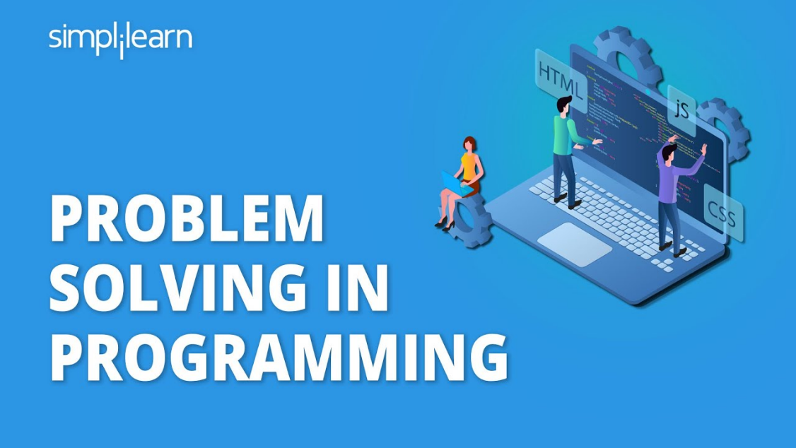
Problem solving in programming is a fundamental skill that involves identifying, analyzing, and solving complex issues or challenges through the creation of software solutions. Here are the key steps and strategies involved in problem-solving in programming:
- Understanding the Problem:
  - The first step is to thoroughly understand the problem you need to solve. This includes understanding the requirements, constraints, and expected outcomes.
- Break Down the Problem:
  - Decompose the problem into smaller, more manageable sub-problems or tasks. This helps in tackling the problem incrementally and makes it less overwhelming.
- Requirements Analysis:
  - Clarify and document the requirements for the solution. Make sure you have a clear understanding of what the software should achieve.
- Research and Gather Information:
  - If necessary, research the problem domain, gather relevant data, and consult documentation or experts to gain insights.
- Plan and Design:
  - Create a high-level plan or design for your solution. This may include sketching out algorithms, data structures, and user interfaces.
- Pseudocode or Algorithm Design:
  - Write pseudocode or outline the algorithm you plan to use. This helps in organizing your thoughts and making the coding process more straightforward.
- Select the Right Tools and Technologies:
  - Choose the programming language, libraries, and frameworks that are most suitable for the problem at hand.
- Coding:
  - Implement the solution by writing code. Follow best practices for coding standards, readability, and maintainability.
- Testing:
  - Thoroughly test your code to ensure that it meets the specified requirements and handles different scenarios and edge cases.
  - Use unit testing, integration testing, and other testing techniques as needed.
- Debugging:
  - If issues or bugs are identified during testing, use debugging techniques to locate and fix them.
- Optimization:
  - Analyze the performance of your code and optimize it for efficiency, if necessary.
  - Profile your code to identify bottlenecks and areas for improvement.
- Documentation:
  - Document your code, including comments, API documentation, and user guides. Well-documented code is easier for others to understand and maintain.
- Version Control:
  - Use version control systems like Git to keep track of changes and collaborate with others effectively.
- Code Reviews:
  - Seek feedback from peers through code reviews. Code reviews can uncover issues, provide insights, and improve code quality.
- Iterate and Refine:
  - Be open to making iterative improvements based on feedback and changing requirements.
- Problem Solving Techniques:
  - Use established problem-solving techniques like divide and conquer, dynamic programming, greedy algorithms, and others, depending on the nature of the problem.
- Ask for Help:
  - Don't hesitate to ask for help from colleagues, mentors, or online communities when you're stuck or facing a particularly challenging problem.
- Continuous Learning:
  - Stay updated with new technologies, programming languages, and best practices. Continuous learning enhances your problem-solving abilities.
- Practice:
  - Regularly practice coding and problem-solving exercises to sharpen your skills.
- Stay Patient and Persistent:
  - Problem solving in programming can be challenging. Stay patient, persistent, and confident in your ability to find solutions.
Effective problem solving is a crucial skill for programmers, as it enables them to create reliable and efficient software solutions that meet real-world needs. Developing good problem-solving habits and practices can lead to more successful and satisfying programming experiences.

Session 6: KM-01-KT06: Life cycle for developing a solution 15%
- IAC0601 Demonstrate the functions and stages of the programming

The stages in the software development life cycle (SDLC) vary depending on the chosen methodology (e.g., Waterfall, Agile, DevOps) and the specific needs of the project. However, here is a generalized breakdown of the stages commonly found in the SDLC:
- Strategy:
  - Goal: Define the overarching goal of the software project, such as solving a specific problem or meeting a business need.
  - Objectives: Specify the measurable objectives that the software solution should achieve.
  - Target Audience: Identify the users and stakeholders who will interact with the software.
  - Competition: Analyze competitors and similar solutions in the market.
  - Platform: Determine the platform or technology stack on which the software will be developed.
- Design:
  - Requirements Gathering: Collect and document detailed requirements from stakeholders and users.
  - Planning: Create a project plan, including resource allocation, timelines, and milestones.
  - Creation and Design: Develop high-level and detailed designs, including software architecture, user interface (UI), and database schema.
- Development:
  - Write code based on the design specifications.
  - Follow coding standards and best practices.
  - Implement software components and features.
  - Perform unit testing to validate individual code modules.
- Testing:
  - Performance Testing: Evaluate the software's speed, responsiveness, and scalability under various conditions.
  - Security Testing: Identify and address security vulnerabilities and threats.
  - Usability Testing: Assess the software's user-friendliness and ease of navigation.
  - Functional Testing: Verify that the software functions as specified in the requirements.
  - Regression Testing: Ensure that new code changes do not introduce new defects.
  - User Acceptance Testing (UAT): Let end-users test the software to ensure it meets their needs and expectations.
- Release and Ongoing Support:
  - Deploy the software to the production environment.
  - Provide user training and documentation.
  - Offer ongoing support for bug fixes, updates, and enhancements.
  - Monitor the software in production and address issues promptly.
- Maintenance and Testing:
  - Continuously maintain and update the software to address bugs and security issues.
  - Perform periodic testing to ensure the software remains functional and secure.
  - Apply patches and updates as needed.
- Feedback and Improvement:
  - Collect feedback from users and stakeholders for continuous improvement.
  - Prioritize and implement enhancements and new features based on feedback and changing requirements.
These stages can overlap or be iterative, depending on the development methodology used. For example, Agile methodologies emphasize frequent iterations and collaboration with users throughout the development process, while the Waterfall model follows a more linear and sequential approach. The choice of methodology and the project's specific needs will influence how these stages are structured and executed.

Session 7: KM-01-KT07: Python core concepts 10%
- IAC0701 Definitions, functions and features of Python core concepts are understood and explained

Concept of Python: Python is a high-level, general-purpose programming language known for its simplicity and readability. Guido van Rossum created Python in the late 1980s and released its first version in 1991. Python's design philosophy emphasizes code readability and allows programmers to express concepts in fewer lines of code than in languages like C++ or Java. Python is versatile and widely used in various domains, including web development, data analysis, artificial intelligence, scientific computing, and more.
Definition of Python: Python is an interpreted, high-level programming language known for its ease of use and elegant syntax. It features dynamic typing, automatic memory management, and a comprehensive standard library that provides ready-to-use modules and functions. Python's simplicity and readability make it an excellent choice for beginners and experienced developers alike.
Functions of Python: Python serves multiple functions and is used for a wide range of purposes in the software development and data science fields. Some of its key functions include:
- General-Purpose Programming: Python can be used for a wide range of programming tasks, from writing simple scripts and automation to developing complex software applications.
- Web Development: Python web frameworks like Django and Flask simplify web application development. Python is also used for server-side scripting and creating web APIs.
- Data Analysis and Data Science: Python has powerful libraries like NumPy, pandas, and Matplotlib, making it a popular choice for data analysis, manipulation, and visualization.
- Artificial Intelligence and Machine Learning: Python is widely used for machine learning and AI development with libraries such as TensorFlow, Keras, and PyTorch.
- Scientific Computing: Python is used in scientific computing and research due to libraries like SciPy and scikit-learn, which provide tools for numerical and scientific computing.
- Automation and Scripting: Python is often used for automating repetitive tasks, file handling, and scripting, thanks to its simplicity and cross-platform compatibility.
- Game Development: Python can be used for game development using libraries like Pygame.
- Desktop Applications: Python's Tkinter library allows developers to create graphical user interfaces (GUIs) for desktop applications.
- Server-Side Scripting: Python can be used for server-side scripting, especially in conjunction with web frameworks.
- Network Programming: Python's libraries like socket and requests make it suitable for network programming and creating network applications.
- Embedded Systems: Python can be used for programming embedded systems and Internet of Things (IoT) devices.
- Education: Python's simplicity and readability make it an excellent choice for teaching programming to beginners.
- Rapid Prototyping: Python's concise syntax allows developers to quickly prototype and test ideas.
- Cross-Platform Development: Python is cross-platform, making it suitable for developing applications that run on different operating systems.
- Community and Libraries: Python has a vibrant community and an extensive ecosystem of libraries and packages, making it a powerful and versatile language.
Python's versatility and rich ecosystem of libraries and frameworks make it an excellent choice for a wide range of programming tasks and applications. Its readability and simplicity also contribute to its popularity among developers.

Session 8: KM-01-KT08: Python syntax 15%
- IAC0801 Explain the definitions, functions and features of Python syntax

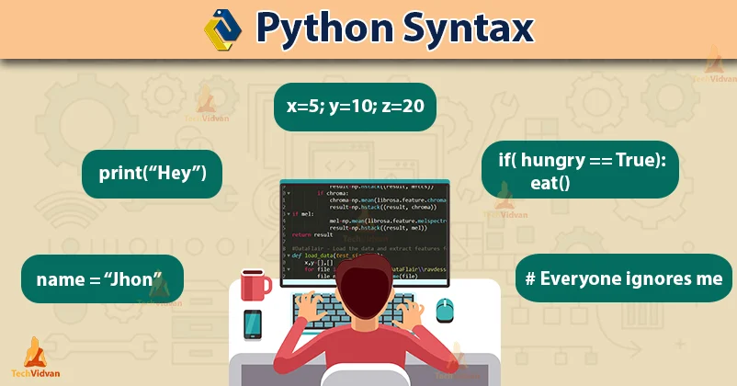
Python syntax refers to the set of rules and conventions that dictate how Python code should be structured and written. Following proper syntax is essential for writing Python programs that are both correct and readable. Here are some key aspects of Python syntax:
- Indentation:
  - Python uses indentation to define blocks of code. Indentation is mandatory, and it is used instead of braces or other delimiters found in some other programming languages.
  - Typically, four spaces are used for each level of indentation, but consistent use of tabs or spaces is crucial to maintain readability.
Example:
if x > 0: print("x is positive") else: print("x is non-positive")
- Statements:
  - Python statements are terminated by newlines (or by a semicolon ; if multiple statements are on the same line).
  - No explicit statement terminators (like ; in C++) are required.
Example:
x = 5 y = 10
- Comments:
  - Comments in Python begin with the # character and continue until the end of the line.
  - Comments are used to provide explanations and documentation within the code.
Example:
# This is a single-line comment x = 5 # This is also a comment at the end of a line
- Variables and Identifiers:
  - Variable names (identifiers) must start with a letter (a-z, A-Z) or an underscore (_).
  - Subsequent characters can include letters, digits, and underscores.
  - Variable names are case-sensitive.
Example:
my_variable = 42 _private_variable = "Hello"
- Reserved Keywords:
  - Python has reserved keywords (also known as reserved words) that have predefined meanings and cannot be used as identifiers.
  - Examples of reserved keywords include if, else, while, for, import, class, and others.
- Whitespace:
  - Whitespace (spaces and tabs) is used for indentation and to separate tokens, but it does not matter how many spaces you use, as long as you are consistent within the same block.
Example:
# Both of these are valid x = 5 y = 10
- Colon:
  - A colon (:) is used to indicate the beginning of an indented block, such as a loop or a function definition.
Example:
for i in range(5): print(i)
These are some of the fundamental aspects of Python syntax that you need to be familiar with when writing Python code. Proper adherence to Python syntax rules ensures that your code is structured correctly and is easy to read and understand by both you and other developers.

Session 9: KM-01-KT09: Python variables 15%
- IAC0901 Explain the definitions, functions and features of Python variables
Concept and Definition of Python Variables:
In Python, a variable is a symbolic name that is used to store and reference data in memory. Variables act as containers that can hold different types of data, such as numbers, text, lists, or more complex data structures. Variables provide a way to store values, perform operations on them, and manipulate data within a program.
Functions of Python Variables:
- Storing Data: Variables allow you to store data values in memory. You can assign values to variables using the assignment operator (=). For example:
x = 42 # Assign the integer value 42 to the variable 'x' name = "Alice" # Assign the string "Alice" to the variable 'name'
- Referencing Data: Once data is stored in a variable, you can use the variable's name to reference and access the data. This makes it easy to work with data in your program.
print(x) # Prints the value of 'x', which is 42 print(name) # Prints the value of 'name', which is "Alice"
- Data Manipulation: Variables allow you to perform operations on data. You can perform arithmetic operations, string manipulation, and more using variables.
y = x + 10 # Perform an arithmetic operation using the variable 'x' greeting = "Hello, " + name # Concatenate strings using variables
- Data Type Flexibility: Python variables are dynamically typed, which means you don't need to declare their data type explicitly. You can change the value and data type of a variable at runtime.
x = 42 # 'x' is an integer x = "Hello" # 'x' is now a string
- Data Scope: Variables have scope, which determines where in the code they can be accessed. Variables declared within a function have local scope and are only accessible within that function. Variables declared outside of any function have global scope and can be accessed throughout the program.
global_var = 10 # Global variable def my_function(): local_var = 20 # Local variable within the function
- Data Sharing: Variables enable data sharing between different parts of a program. They can be used to pass data between functions, modules, and different parts of the code.
def calculate_total(price, quantity): return price * quantity total_cost = calculate_total(5.99, 3) # Pass data to a function and store the result in a variable
Python variables are a fundamental concept in programming that allows you to work with and manipulate data efficiently. Understanding how to declare, assign, and use variables is crucial for writing Python programs.

KT0902 Variables
In Python, variables are used to store and manage data. Variables are essentially symbolic names or identifiers that reference a specific location in memory where data is stored. Here are some key points about variables in Python:
- Variable Assignment:
  - To create a variable, you use the assignment operator = to associate a name (the variable name) with a value (the data to be stored).
  - Variable names should follow certain rules:
    - They can include letters (both uppercase and lowercase), digits, and underscores.
    - They cannot start with a digit but can start with an underscore or a letter.
    - Variable names are case-sensitive (myVar and myvar are treated as different variables).
Example:
name = "Alice" # Assign a string value to the variable 'name' age = 30 # Assign an integer value to the variable 'age'
- Dynamic Typing:
  - Python is dynamically typed, which means that you don't need to declare the data type of a variable explicitly. The interpreter determines the data type based on the assigned value.
  - You can change the value and data type of a variable at runtime.
Example:
x = 42 # 'x' is an integer x = "Hello" # 'x' is now a string
- Data Types:
  - Python supports various data types, including integers, floating-point numbers, strings, lists, tuples, dictionaries, and more.
  - Variables can store values of any data type.
Example:
num = 42 # An integer variable price = 29.99 # A floating-point variable message = "Hello, World!" # A string variable
- Variable Scope:
  - Variables have scope, which defines where in the code the variable can be accessed.
  - Variables declared within a function have local scope and are only accessible within that function. Variables declared outside of any function have global scope and can be accessed throughout the program.
Example:
global_var = 10 # This is a global variable def my_function(): local_var = 20 # This is a local variable within the function
- Naming Conventions:
  - It's good practice to use descriptive variable names that convey the purpose or meaning of the data they store.
  - Follow PEP 8 naming conventions for variables, which typically use lowercase letters and underscores for variable names (my_variable, data_value).
Variables play a central role in Python programming as they allow you to store, manipulate, and reference data efficiently. Understanding how to work with variables is fundamental to writing Python code.

